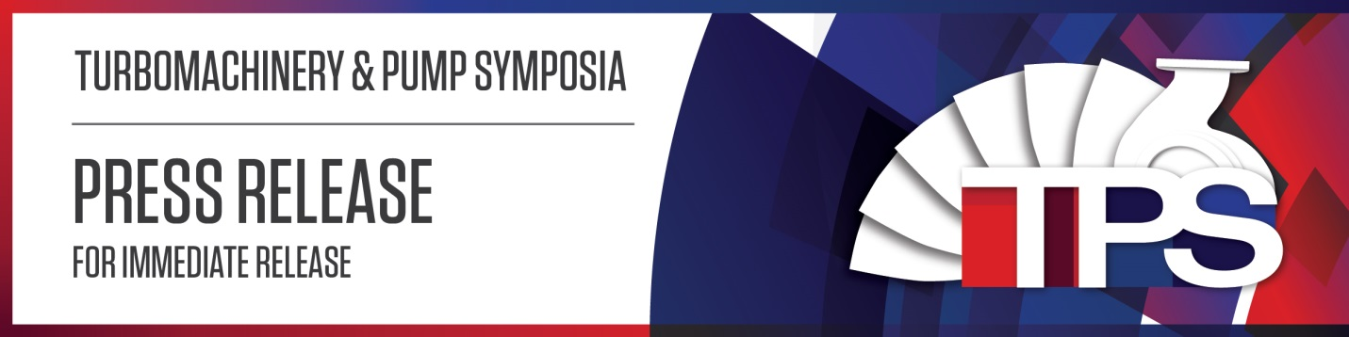
August 14, 2017
Turbo Lab to host 46th Turbomachinery and 33rd International Pump Users Symposia
HOUSTON, Texas— The Turbomachinery Laboratory at Texas A&M University is embarking on its 46th Turbomachinery and 33rd International Pump Users Symposia (TPS 2017).
TPS is the premiere conference for rotating equipment engineers and technicians worldwide, spanning oil and gas, petrochemical, chemical, power, aerospace, and water industries. The expert-selected technical program combined with an international exhibition spanning 216,000 gross square feet is the perfect platform for networking with colleagues and suppliers, and learning about new problem-solving methods and technologies.
DETAILS
TPS 2017 will be held at the George R. Brown Convention Center in Houston, Texas, Sept. 12 – 14, with full-day short courses offered on Monday, Sept. 11 in conjunction with the symposia. Paid symposia delegates may choose to engage in a combination of 15 short courses, 23 lectures, 17 tutorials, 23 discussion groups and 21 case studies led by industry experts from around the world. Continuing education credits are offered for all technical sessions.
The symposia exhibition will feature booths from more than 350 leading companies from the oil and gas, petrochemical, power, pump and turbomachinery industries. Companies will display full-size equipment, cutting-edge technology and emerging industry trends. During a portion of the symposia, the exhibit hall will be free to the public upon completion of a free pass registration form. Free entry will be available Tuesday, 2:30 – 7 p.m., Wednesday, 2:30 – 6:30 p.m. and Thursday, 9:30 a.m. – noon.
OVERVIEW
Built on a history of success, the annual TPS promotes professional development, technology transfer, peer networking and information exchange among industry professionals. TPS 2016 boasted an attendance of more than 5,400 and featured more than 350 exhibiting companies from 48 countries.
“We are pleased to host another symposia—the meeting of choice for users and manufacturers of commercial turbomachinery,” said Dr. Dara Childs, director of the Turbo Lab, chair of the TPS advisory committees and Leland T. Jordan Chair of Mechanical Engineering at Texas A&M University. “This is where the best in the industry come to share their expertise. The countless networking opportunities alone make TPS worthwhile. It’s an opportunity you can’t afford to miss.”
Childs, who has been with the Turbo Lab since 1980, will retire following TPS 2017. He will be honored at the symposia during the Wednesday evening banquet. The banquet will be held in the Hilton Ballroom of Americas A at 7:30 p.m. Paid delegates and exhibitors receive entry with their badge. Individual tickets are available for purchase in Hall C on the first floor of the George R. Brown Convention Center.
Registration remains open online and will be available on site for paid symposia and free pass delegates. For more information on TPS 2017, including the full technical program, event schedule, exhibiting company list, registration procedures and more, please visit tps.tamu.edu.
###

The Texas A&M Engineering Experiment Station (TEES) Turbomachinery Laboratory conducts basic and applied research into important problems of reliability and performance of turbomachinery—rotating machinery that extracts or adds energy to fluids, including everything from classic Dutch windmills to a space shuttle’s main engine turbopumps and compressors. The Turbo Lab offers engineering education through Texas A&M University’s Department of Mechanical Engineering, and provides continuing education opportunities to industry professionals at annual symposia and short courses, advancing Texas A&M’s land-grant charter tradition of education, research and service.

Media Contact:
Brooke Conrad
Office: 979-845-8943
Cell: 979-224-6991
bconrad@turbo-lab.tamu.edu
marketing@turbo-lab.tamu.edu

